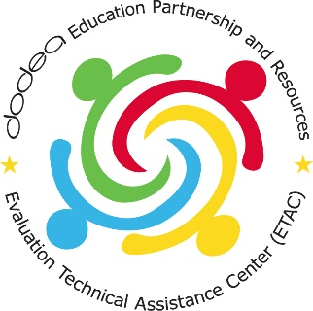
DoDEA Grantees Suggested Social Media Posts and Outreach
These sample social media posts are what Safal Partners suggests posting to your Facebook, Instagram, and Twitter accounts during the month of April for the Month of the Military Child. The following accounts will also be posting and retweeting photos, videos, and stories from celebrations around the world; feel free to repost or retweet from your school’s accounts.
- DoDEA HQ: https://www.facebook.com/DoDEA.edu
- DoDEA Americas: https://www.facebook.com/DoDEAAmericas
- DoDEA Europe: https:/www.facebook.com/DoDEAEurope
- DoDEA Pacific: https://www.facebook.com/DoDEA.Pacific
- DoDEA Grantees: https://twitter.com/dodeagrants
- Safal Partners Twitter: https://twitter.com/SafalPartners
- Safal Partners Facebook: https://www.facebook.com/SAFALPartners/
Hashtags
- #MonthoftheMilitaryChild
- #DoDEAGrants
- #PurpleUp
- #PurpleUpforMilitaryKids
Other Outreach
We also suggest asking your surrounding community to take part in Purple Up! For Military Kids by wearing purple on the day of your event or month-long. This includes people such as:
- Parents and families
- Elected Officials
- Local community representatives
- Local workforce boards
- Local chambers of commerce’
Ask them to share their photos, videos, and stories using the hashtag #MonthoftheMilitaryChild or to tag your social media accounts.
Sample Post 1
(Right click and save the PNG file/image below to use it on your social media channels)
Twitter: We’re excited to kick off #MonthoftheMilitaryChild this April! This month underscores the important role #militarykids play in the armed forces community. #DoDEAGrants @DoDEAGrants @DoDEA
Facebook/Instagram: We’re excited to kick off the Month of the Military Child this April! This month underscores the important role military children play in the armed forces community.
More details to come! For more information, visit https://www.dodea.edu/dodeaCelebrates/Military-Child-Month.cfm.
LinkedIn (If available): We’re excited to kick off the Month of the Military Child this April! This month underscores the important role military children play in the armed forces community.
More details to come! For more information, visit https://www.dodea.edu/dodeaCelebrates/Military-Child-Month.cfm.

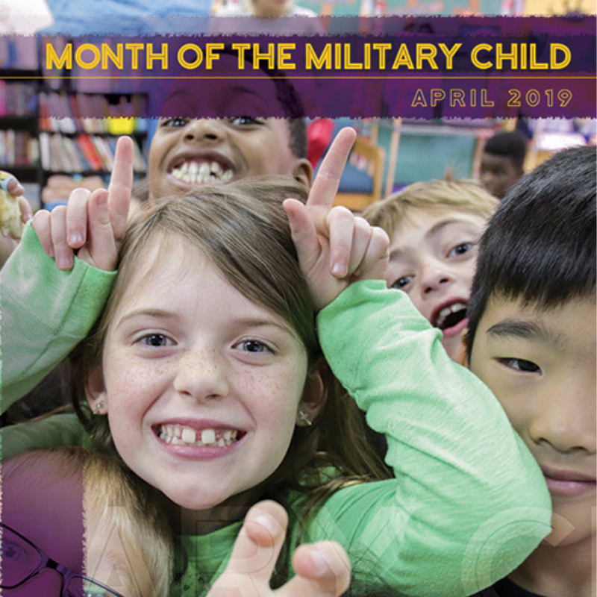

Sample Post 2
(Right click and save the PNG file/image below to use it on your social media channels)
Twitter: It’s time to PURPLE UP! For Military Kids this April! Show military children across the world that you support them by wearing purple this [INSERT DATE OF YOUR SCHOOL’S PURPLE UP DAY]. #PurpleUpforMilitaryKids #MonthoftheMilitaryChild #DoDEAGrants
Facebook: It’s time to PURPLE UP! For Military Kids this April! Show military children across the world that you support them by wearing purple [INSERT DATE OF YOUR SCHOOL’S PURPLE UP DAY]. Share your photos us with us in the comments!
For more information on the Month of the Military Child, visit https://www.dodea.edu/dodeaCelebrates/Military-Child-Month.cfm.
LinkedIn (If Available): It’s time to PURPLE UP! For Military Kids this April! Show military children across the world that you support them by wearing purple [INSERT DATE OF YOUR SCHOOL’S PURPLE UP DAY]. Email your PURPLE UP! photos to us at: [INSERT SCHOOL EMAIL ADDRESS HERE]

Sample Post 3
(Right click and save the PNG file/image below to use it on your social media channels)
Twitter: Here are some ideas on how you can celebrate #MonthoftheMilitaryChild with us this April. Find more ideas at https://www.dodea.edu/dodeaCelebrates/Military-Child-Month.cfm. #DoDEAGrants #MilitaryKids
Facebook/Instagram: Here are some ideas on how you can celebrate #MonthoftheMilitaryChild with us this April.
Find more ideas at: https://www.dodea.edu/dodeaCelebrates/Military-Child-Month.cfm
